**SUGAR INDUSTRY NEEDS LONG DELAYED JUSTUCE**

**BY**

**SYED MUHAMMAD SHIFAAT ZAIDI**

**FORMER PRESIDIENT**

**PAKISTAN SOCIETY OF SUGAR TECHNOLOGISTS (PSST)**

**Hon’ble Syed Murtaza Mehmood Sahib,**

**Federal Minister for Industries & Production,**

**Government of Pakistan**

Mr Zahid Mehmood Qureshi, President and office bearers of PSST,

Ladies & Gentlemen

**ABSTRACT:**

**Rise & fall of prices is a normal phenomenon all over the world with no exemption to any commodity. There are always reasons for increase & decrease in price of any item. Most important factor is demand & supply. However, in Pakistan, Sugar has been found to be the most sensitive item. It has been observed that no one would take any notice if the price of any particular commodity increases tremendously or even by 100 % but an increase in the price of sugar in Pakistan by a few rupees / kg, would always bring vast criticism on this industry which alone has contributed in the progress of rural economy & prosperity of farmers more than rest of the industries. In case of surplus sugar production, the decision for export is mostly taken after a lot of delay. Please allow me to repeat the old proverb "A stitch in time saves nine ".**

Hon’ble Minister,

It is not an ordinary coincidence that twenty five years ago I was given the opportunity by the FPCCI to give a presentation before your Hon’able father Makhdoom Ahmad Mehmood Sahib who was Federal Minister for environment at that time on “Importance of Sugar Industry and Environment” at Hotel Pearl Continental, Karachi on 4th September 1997. Fortunately it was the first presentation on environment from sugar Sector, like environment was also a new subject in Pakistan.

Sir,

I am grateful to the office bearers of PSST for providing me this opportunity to take your precious time to explain some important points which you may like to submit before the Prime Minister for necessary action purely in the national interest.

Sir,

Not only as Federal Minister for Industries & Production but also as a renowned landlord, you are fully aware of the contribution of this industry in the uplift of rural areas & prosperity of farmers in the country. Please note one thing carefully that “continuity of good policies must always be ensured”

Sir,

It will not be out of question to inform you that at the eve of our 49th Convention’ I had presented a paper on the subject, “ Sugar Industry Needs Justice” on 14th Sep;2015 in presence of Mr, Sikandar Hayat Boson, Federal Minister for Food & Agriculture. This paper has also been published by a few magazines including Pakistan Sugar Journal” A lot of my friends in the Sugar Industry have not only requested but forced me to present this paper again at this Convention” Therefore I have updated that paper as per requirements of the day.

It was in the year 2000 that the World Bank advised the Government of Pakistan to close down certain industries including Sugar, Oil Refining, Chemicals, Auto, Fertilizer and Steel. Studies sponsored by them on these industries in all likelihood state that these were inefficient industries and should be closed down. One may call performance of sugar industry of Pakistan inconsistent but was never inefficient. Our sugar production in 1947-48 was merely 8109 tonnes & had risen to over 3.5 million tonnes in 1997-98, It was in the backdrop of this advice that the then Government of Pakistan decided to face this challenge and revived various boards like Sugar Advisory Board, Cotton Advisory Board, Wheat Advisory Board, Rice Advisory Board etc. after more than 20 years. How is the industry replying to this challenge? After 22 years of the World Bank advice we can see that Steel Mill is closed for the last so many years and we all know the condition of Sugar industry. **(Out of 92 Sugar Mills, 78 are in operation & 14 closed). Yet, we have produced almost 8.0 million tonnes Sugar highest ever during 2021-22). High or low sugar production always increased problems for this industry due to no or delayed decisions. As a result of higher production, payments to farmers. had to be delayed as Banks did not help Sugar Mills & Sugar industry faced the ire of farmers &Government.**

So, the Boards started functioning and after a lot of efforts, we were able to see the National Sugar Policy 2009-10. Salient features of National Sugar Policy are reproduced below. Fortunately, I also served as a Member & later on Co-opted Member of this Board.

2.2**: SUGAR CANE PRICING AND SUCROSE CONTENT:** Currently the 'Sugarcane Price Notification' ignores the sucrose content of sugarcane. Farmers growing high sucrose content sugarcane are not rewarded with higher price. The farmers producing low sucrose content sugarcane have no incentive to cultivate better varieties. Instead of using 'quality content criteria in terms of sucrose all sugarcane varieties are still priced on weight. Even though Pakistan ranks sixth in terms of area harvested under sugarcane out of 16 major cane producing countries, we are placed at fifteenth on the list, in terms of both cane yield and sugar yield. This shows that the sugarcane cultivation in Pakistan is faced with many problems and the situation needs to be addressed on priority.

3.21: The Federal and Provincial governments have been periodically introducing policy measures to facilitate sugar millers and sugarcane growers.

4.2: **Long Term Policy:**

4.21: Sugar Market Pricing: The domestic market will be integrated with the international market by providing necessary tariff protection. A study may be undertaken to redefine details of achieving fully competitive market for sugar trade.

4.22: Price of Sugarcane to be fixed according to Sucrose content: Mechanism of pricing sugarcane on sucrose content shall be introduced in all provinces. As recommended by the Sugar Advisory Board the prices be fixed variety wise initially and afterwards the pricing methodology shall be upgraded in phases in accordance with the best international practices. To achieve this purpose as test case two to three mills in each province will be encouraged to subscribe to this practice during 2009-10.

4.23: Research and use of high yield/ high recovery varieties: Provincial Agriculture Research Institutes in collaboration with the private sector should evolve site/ area specific sugarcane varieties through Research and Development of high yield/ high recovery characteristics. To supplement the existing initiatives two dedicated projects with latest technology based on public-private partnership are being set up to be executed by Ministry of Food and Agriculture.

However, it was unfortunate that soon after this policy was notified, 18th constitutional amendment was passed by the parliament. As a result, various ministries including Food & Agriculture were abolished & powers were delegated to the provinces. In the absence of Federal Ministry of Food & Agriculture, all important issues explained at 4.22 & 4.23 could not be achieved. This resulted in a tug of war between the stakeholders. Arbitrary increase in the price of Sugar cane without any consideration for the cost of Sugar Production has proved counterproductive & turned most of Sugar mills in Pakistan sick with the exception of those located in South of Punjab & Ghotki district in Sindh.

Sir, the woes of Sugar industry continued to increase as sugar policy 2009-10 was thrown in the cold storage. People in the Government forgot if there was any such document. Sugar production in Pakistan during the seasons 2016-17 & 2017-18 was 7.05 and 6.621 million tonnes. This brought more woes to this industry as timely export was not allowed & prices in the domestic market fell below the cost of production. This resulted in less cultivation of Sugar cane & domestic production in 2018-19 & 2019-20 fell to 5.27 & 4.88 million tonnes much below domestic requirements. Increase in the price of sugar in Nov; 2019 brought more problems for this industry as domestic price of sugar increased considerably.

We can increase the price of any commodity to any level & no one will take any notice but increase in the domestic price of sugar is a big crime & can’t be forgiven. Let us see the following figure

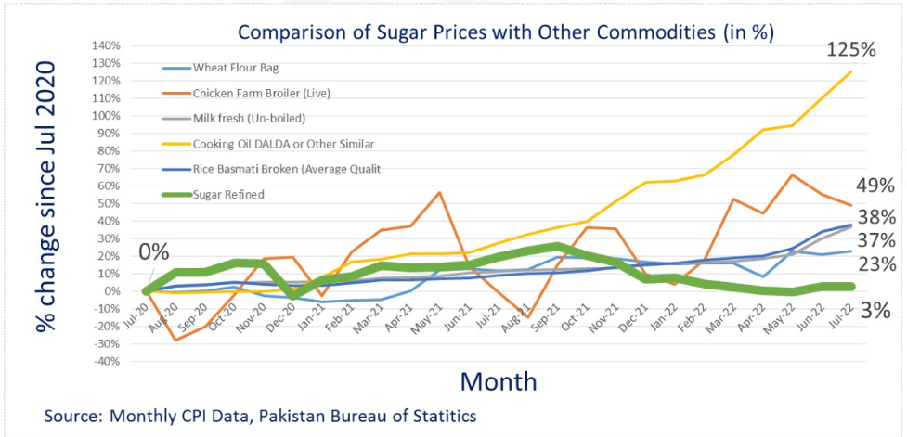

As a result of increase in Sugar Price, a Sugar Commission headed by DG; FIA was formed to investigate...............................

I also appeared before the Commission on May 06, 2020 (12th day of Ramadan,1441 H), travelled from Karachi to Islamabad in my personal car as no flights, Railways & Public transport was plying due to Covid 19 Pandemic.

However, I was able to clarify a few misunderstandings & the Commission submitted its report to the then Prime Minister of Pakistan & “ Sugar Sector Reforms Committee” headed by Mr. Hammad Azhar, Federal Minister for Industries & Production was formed. The Committee submitted its report in Dec;2021.

The committee was tasked to study the following important points:

As per report

4. International best practices

4.1 Overview of global sugar market

4.2 Historical trend of world sugar crises

4.3 Overview of India’s sugar policy

4.3.1 Sugar Price Control in India

4.3.2 Sugarcane control order 1966

4.3.3 Import and Export

4.4 Overview of Thailand’s sugar policy

4.4.1 Reforms

4.5 Canada’s open market sugar policy

5 Proceedings of the committee

The committee met 7 times between July, 2020 and March 2021

Sugar policy 2009-10 was also reviewed besides presentations were made by DG FIA, Ministry of Food Safety & Research, SUPARCO, brief by province of Punjab on relevant laws, presentation by SECP & SUPARCO on five years data on sugarcane. Last presentation was made by Law Division.

( Ironically NO SUGAR EXPERT WAS A MEMBER OF THIS COMMITTEE)

It has been a normal practice for so many years that Provincial governments fixed the price of sugarcane but this could hardly be implemented. At times the rates of sugarcane changed upwards not only day by day but in certain cases after a few hours. Now farmers are demanding Rs, 400 to 500 per 40 kg supplies of sugarcane.

Following table gives a clear picture of share of cost of sugar cane per Kg sugar produced at various recoveries ranging between 8.0 and 13.0.



This year our sugar production from sugarcane and sugarbeet has been recorded to be approximately 8 million tonnes. Our domestic requirement is not more than 6 million tonnes. This means that around 2 million sugar is surplus which can be exported and fetch a revenue of One Billion US$. In spite of all efforts by the millers the Govt is not allowing any export. Under the false apprehension that there may be paucity of sugarcane and sugar in the next year because of after effects of heavy rains and floods. Shortage of sugar and sugarcane seems highly improbable. Reason being, the plantation of sugarcane through scientific means has been recorded at least 10% more than last year. The damage to crop from floods cannot be more than 15% to 20%. With all pros and cons sugar prediction in the next year will be in the range of 6.7-7.2 million tonnes still surplus than our domestic requirements.

Since export has not been allowed & Banks are reluctant in financing to Sugar Mills, Sugar Mills are not able to clear payments to farmer & sugar price are also maintaining a lower trend in the local market. detrimental to the interest of Sugar industry. Look at the following chart depicting prices of all essential commodities since 1991.

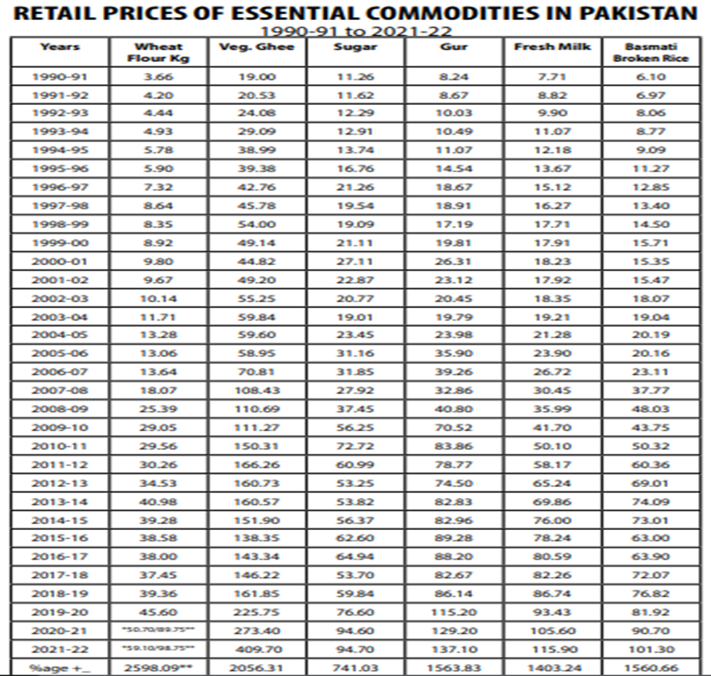

Sugar industry is perhaps passing through the most crucial period.  Most of sugar mills are bleeding. A highly prosperous industry is now struggling for its survival. A few Sugar Mills did not operate last year. A few more may not operate this year. There are shadows of unemployment. Most of the people associated with this industry seem to be frustrated. Most of Investment is adding to liabilities. Sugar price in the international market is around US$ 500 per tonne. Where have we gone wrong? Is it bad planning or some other reason but one thing is sure, interest of all the stake holders particularly that of Sugar industry needs to be reviewed carefully. Sugar industry has the right to survive & therefore, needs justice , long delayed justic

Sugar industry is in a big problem and sugar cane growers are also not happy due to payment issues. To resolve this issue sugar industry needs support from the Government, State Bank as well as Commercial Banks. Sugar industry urgently needs a special package. Special credit lines at very low markup rate say about 5% must be offered to sugar industry only for sugar cane payment. This will enable the industry to make prompt payment to farmers.

Sir, it is already, too, late we have not implemented the recommendation of National Sugar Policy 2009-2010. Time has come that the recommendations of this policy are implemented in letter and spirit without any further delay. I feel that there is a dire need to study and analyze the factors which are making industries in this country unviable. We need a forum comprising of highly capable economists, agricultural and industrial experts at this critical juncture that might offer a solution by building a bridge between the industry and farmers. This forum can undertake industry related work and try to respond to this challenge in a professional way. Our existing research centers can deliver but are unfortunately unable to respond to this challenge as various factors have taken their toll. We must focus on a one point agenda that we have to protect the interest of all the four stake holders, I mean Farmers, Industry, Government and Consumers. Neither farmers nor industry can survive without protecting the rights of each other.

THANK YOU